
Assignment 2
Name: Jeebak Sabu
Student ID: 48085847
Course Code: BUSA8000
Word Count: 1756

Acknowledgement Statement by students

I acknowledge that I have only used GAITs (e.g., ChatGPT) in drafting and proofreading this assignment, which is permitted in the assignment instructions.

Introduction
Business professionals need to be able to evaluate and understand complicated datasets because our world is becoming more and more data driven. To help koala conservation efforts, this research focuses on using business analytics techniques to take advantage of data and extract insights that can guide strategic decision-making. Data cleansing, data visualization, and statistical analysis of koalas' physical and biological traits will all be part of the analysis. The objective is to find important patterns and connections in the dataset using Python and appropriate modules, which will ultimately assist with more comprehensive conservation strategies.

The assignment replicates a real-world situation where data analysts must analyse complex data to get useful conclusions. In this report, I'll show you how the many methods I covered in class are used to tackle practical business issues with an emphasis on environmental preservation. The results will demonstrate a deeper comprehension of business analytics and highlight its importance in addressing global ecological concerns.

Section 1: Exploratory Data Analysis
I named the data frame koala_data to easily distinguish the data frame in my analysis. In the initial part of the first section, I focus on preparing the dataset for analysis by cleaning the data. After importing the data, the first step is to understand what the data consists of by looking up the top and bottom values along with the summary, which talks about the datatype that the dataset contains, and descriptive statistics, to summarize features from the set of information.
Checking for Unique and duplicate values
I checked for unique values, majorly in 'region’, ‘gender’, and ‘habitat’. I found a couple of values that need to be replaced in the column’s ‘gender’ and ‘habitat’. So, I chose to replace them with their correct values, which go best with the data.
I then check for duplicate rows. But after running my code, there don’t seem to be any duplicate values that will hinder my analysis.

Handling missing values

I check for the null values in the data frame and notice there are 6 rows with at least 1 NaN value. I decided to replace the missing values with median based on gender as there is a possibility that male and female koalas may have different traits. Replacing them based on gender may provide more accurate data to do the analysis.

Handling Outliers

I decided to handle outliers by first checking which columns contain outliers using Boxplot. I chose this way of dealing with outliers because it is easier to normalize the data and fix the skewness this way.
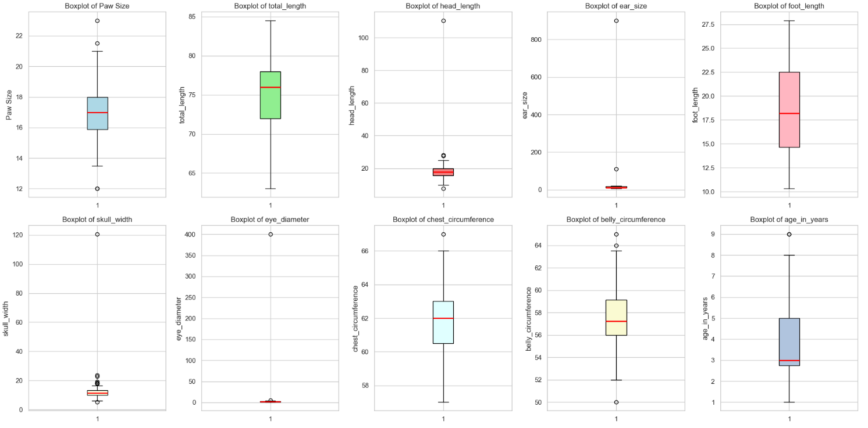
I noticed there are quite a few outliers in different columns. These outliers can cause hindrance to the result of my analysis. Since there are outliers, there is a high chance, the columns are highly skewed as well. So, I check for skewness using histograms and notice a couple of columns that are highly skewed.
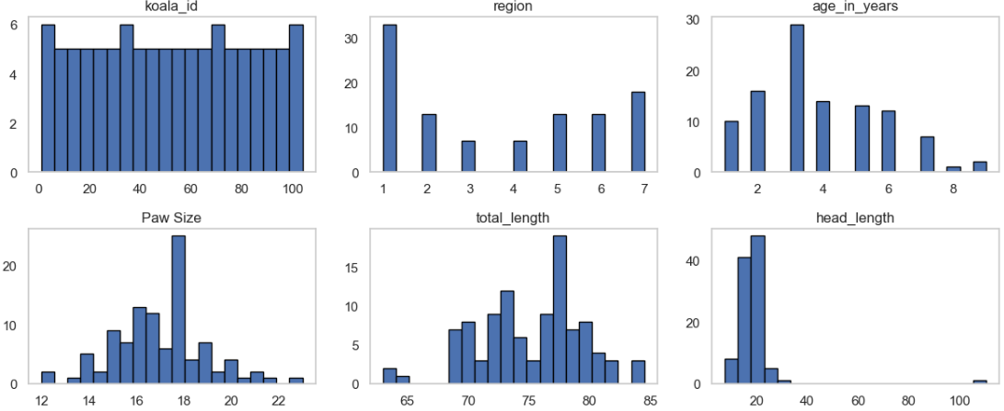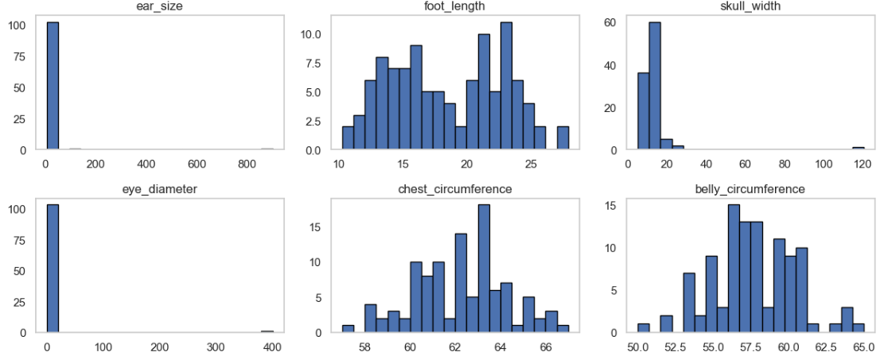

I then decide to replace the outliers using the IQR method and replace the lower and upper bound values with median, categorized by gender, as replacing with median is less sensitive when compared to mean, which is better in this scenario as the dataset has extreme outliers. This suited best for my analysis as it wouldn’t change the given data in a big way. Now the data is uniform throughout all columns.

Even after replacing the outliers, I did find a few outliers (as shown in the image). These outliers aren’t big enough to change the result of my analysis, so I decided to keep them. Since we are dealing with biological data, keeping outliers that are not too extreme might benefit me because some koalas naturally might have traits based on the habitat and region, they grow up in. This will eventually provide a more realistic assessment of my analysis.
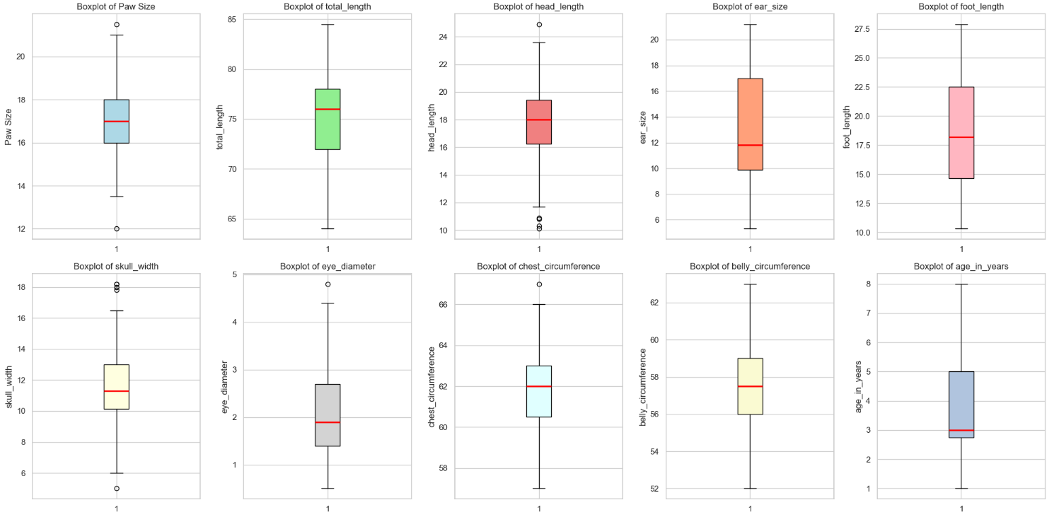

I finally check for skewness just to be sure if there are any values that don’t fall under the acceptable range of -1 to 1. But since the data is uniform after fixing the outliers with median, the skewness range falls between the acceptable values.
Section 2: Data Visualization
I decided to go with 2 insights, each explaining certain important information from the cleaned data
Insight 1: Koala characteristics by habitat
For the first visualization I used a scatter plot to understand how the total length changes with respect to age across different habitats.
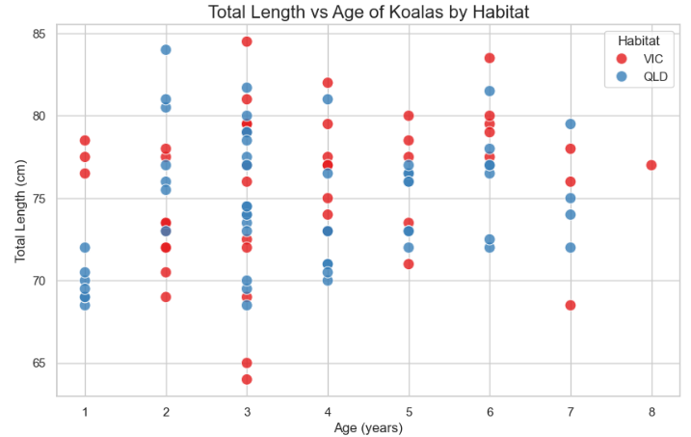
From the visualization, I notice that younger koalas between 1-3 years of age; the data is relatively within a smaller range around 70 to 80 cm; there is a little spread, which basically suggests that younger koala's have more uniform total length regardless of the habitat. On the other hand, in older koala’s 4–7 years, the variations slightly increase as there is a possibility that individual growth rates and a couple of environmental factors can influence body length, resulting in a higher total length. There are also a few points where the total lens is above 80 cm; this can possibly be due to certain conditions within the habitat that might cause a few koalas to exceed the usual growth expectations.
Another visualization that I used was a bar plot I used paw size, foot length, and head length to do the analysis because koalas rely majorly on their pose for climbing trees and it is essential for survival, foot length since it is important for better stability in trees; and head length as koalas head could be linked to different behavior and diet. These factors majorly influence the data, which is the reason I choose to visualize it.
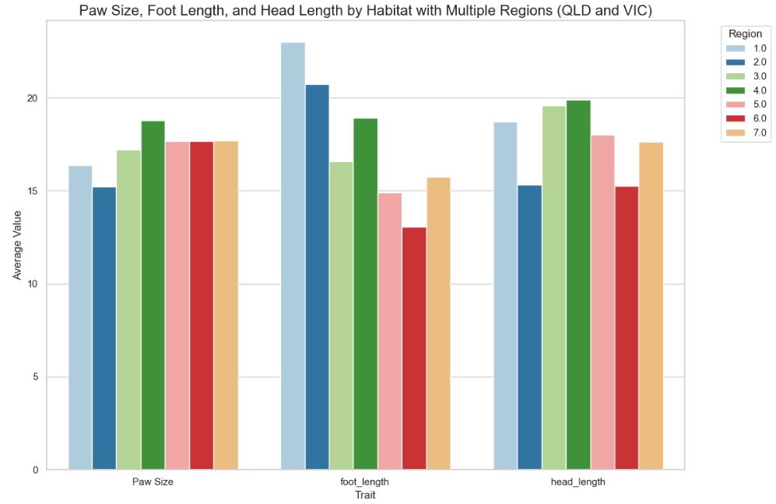
The visualization above shows significant variation in koala traits across different regions in Queensland and Victoria. Regions such as 4.0 show a consistently higher trait average; on the other hand, 6.0 shows a lower average. The chart also shows that foot length and head length are more variable, possibly due to the different environmental factors across the region, whereas paw size is more consistent.
Insight 2: Koala characteristics by habitat
I first used a pair plot to compare the koala traits like head length, paw size, etc. across regions.
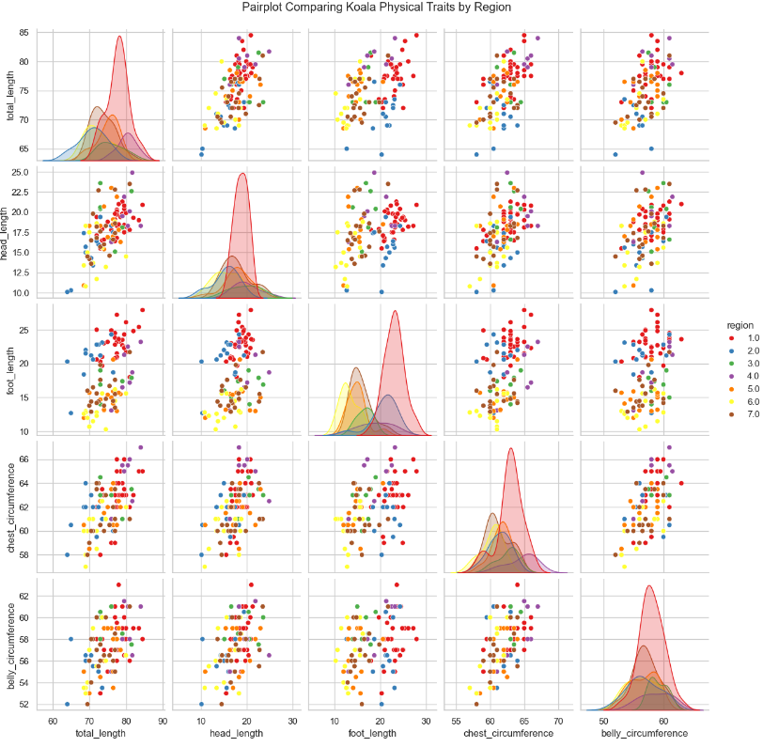
There seems to be a strong positive correlation between several traits. Koalas with higher total length also tend to have larger foot length, chest circumference, and belly circumference, showing that their traits grow proportionally. Some traits, like head length, show a weaker correlation with total length, as it might vary based on the genetics of individual koalas and regions.
Another visualization I used is a spider plot that compares the physical traits of koalas by gender. In terms of most characteristics, the profiles of male and female koalas are similar. According to the measured attributes, male and female koalas have remarkably similar physical features, as indicated by the lines for males and females almost overlapping in most places.
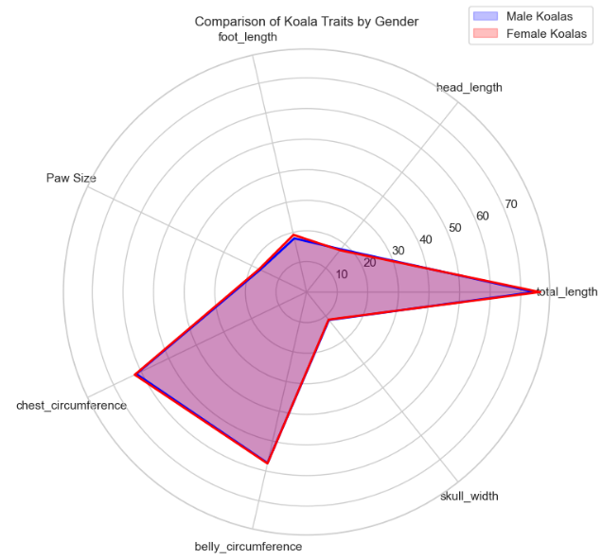
Given that the two sexes are roughly the same size and proportion, it appears that sexual dimorphism in koalas is not evident in these characteristics. There is a possibility that when the data was collected, female pregnant koalas weren’t considered, or no female koalas were pregnant at that moment. If this data were present, there would have been a significant difference in the data.

Section 3: Analysis
Is the mean head length of the Koalas significantly different from 92.0 mm?
I used a one-sample t-test to see if the koalas' mean head length deviates significantly from 92.0 mm (9.2 cm). This test will determine whether there is a statistically significant difference between the sample mean of the koalas' head length and the population value of 92.0 mm (9.2 cm). The mean head length comes out to be 17.727 cm and p-value < 0.05, which is significantly different from the population value of 92.0 mm.
Do male and female Koalas have significantly different mean head lengths?
Since there are two independent groups (male, female), I used two sample t-tests to see if male and female koalas have significantly different mean head lengths. The p-value is > 0.05, and male mean head length is 17.90, female mean head length is 17.48. This means there is no statistically significant difference.
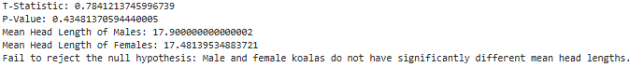
Can we predict the total length of a Koala based on its head length?

Based on the regression analysis, head length is a statistically significant predictor of total length. The R-square value shows that head length does explain some form of variation in total length (35.4%).
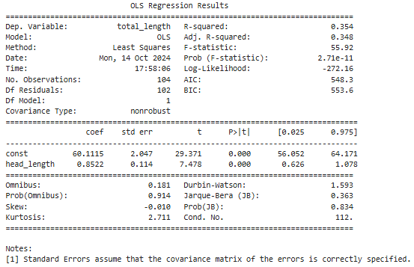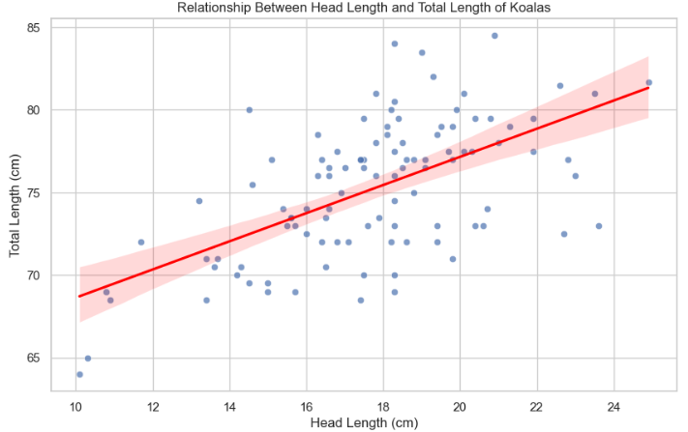

Can we predict the total length of a Koala based on multiple factors such as head length, skull width, and foot length?

All three predictors are statistically significant, explaining the variation in total length. The R-square value is 49.2%, which explains almost half of the variability of total length.
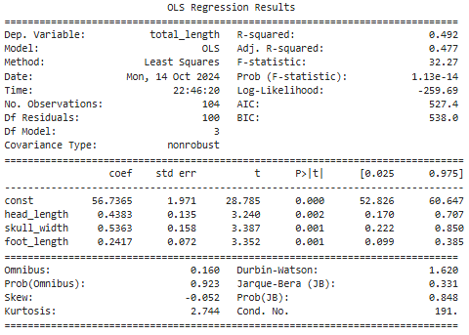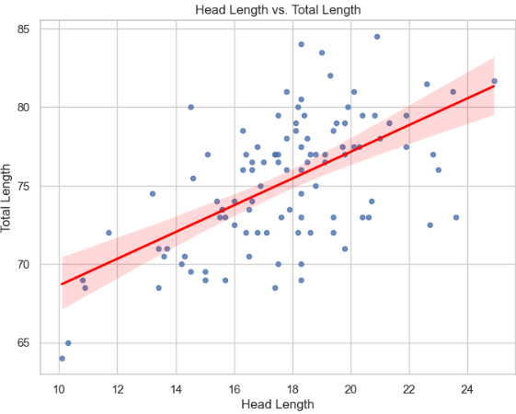

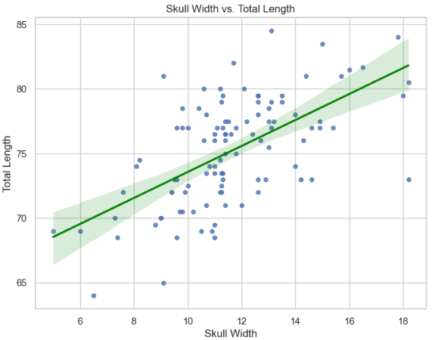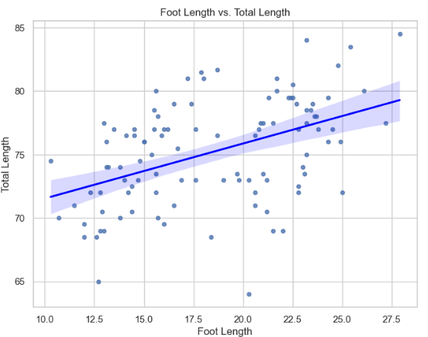
Do environmental factors such as state affect Koala’s physical characteristics?

Since there are multiple regions involved, I chose to use the ANOVA method. As per my analysis traits like head length, foot length, and paw size are significantly influenced by the region. The p-value for all the traits falls below 0.05, making it statistically significant.

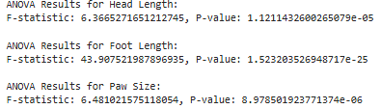

What factors are correlated with the total length of a Koala?

Based on the regression analysis, the correlated values are paw size, head length, and foot length, which are significant predictors of total length as their p-value is<0.05. As for eye diameter, belly circumference, skull width, and chest circumference do not show a major relationship with total length. The model shows 69.6% of the variation in total length, which gives a good understanding of what influences total length.
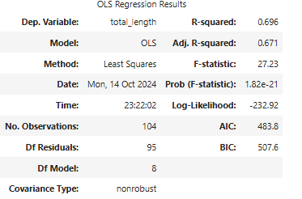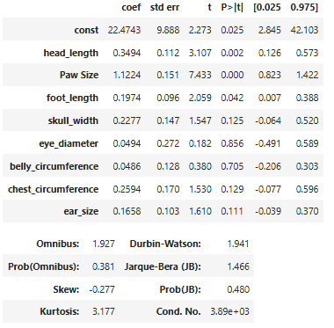

Section 4: Recommendation
1. Restoration and Protection of Habitats:

The strong relationship between total length and paw size, head length, and foot length may indicate that habitat quality affects these physical traits.
Protecting and restoring koala habitats should be a top priority in conservation plans, especially in areas where larger koalas are found because these traits may be associated with reproductive success and general health. Healthy growth and physical condition will be supported by maintaining high-quality eucalyptus forests and making sure there is a wide mix of plant species.

2. Assessing Signs of Physical Health:

Measurable physical characteristics that have a strong correlation with total length and maybe health include paw size, head length, and foot length.
Regular measurements of physical characteristics (paw size, head length, and foot length) should be a part of health evaluations in koala monitoring programs. These characteristics may be used as early warning signs of habitat suitability and population health.

3. Targeted Preservation for Regional Variations:
Although head length, paw size, and foot length are significant overall, the analysis revealed variability in how other traits (like skull width, belly circumference, or ear size) relate to total length. This may point to regional differences in how koalas develop based on environmental conditions.
The investigation showed variation in the relationship between total length and other features (such as skull width, belly circumference, or ear size), even though head length, paw size, and foot length are significant overall. This could indicate that koala development varies by location depending on environmental factors.
Given that koalas in various states or ecosystems may exhibit distinct growth patterns or physical adaptations, conservation efforts ought to be region-specific.

4. Dealing with Climate Change:

Changing environmental conditions, like as climate change, can impact habitat quality, food availability, and water supplies, which may have an impact on the link between physical traits and the total length.
Plans for koala conservation should include climate adaptation measures, especially for areas that are anticipated to experience habitat degradation or changes because of higher temperatures or more frequent droughts.

